Wynoochee Wildwood Executive Board Candidates 2024

John Stevens- Vice President position
Hi! My name is John Stevens. I am running for the position of Vice President for the Wynoochee Wildwood Board.
My sister (Joce) and I purchased lot N7 in April of 2023. I have grown up in Grays Harbor and throughout the years before we purchased our lot would come to Wildwood and spend time camping with friends at various times throughout the year. I made a joke to my mom, Rhonda, last year about lots for sale and before we knew it, we were purchased our lot. Along with my daughter Jameson, my nephew Maddox, and my mom we have been putting a lot of hard work updating our lot while enjoying the fun activities through the year the Board has hosted. Notably we enjoyed the participating in the color run, 4th of July parade, hosted a table for the 4th of July poker run and the cornhole tournament.
My sister and I have chosen throughout the year to continue to enjoy Wildwood and spent Thanksgiving weekend as well as a weekend in February camping with friends on our lot. I try and come through the park every couple of weeks to check on the flooding, I live in Satsop and work in Aberdeen, and have gotten to know most of the lot owners around us so we have contact in the event there is some sort of emergency.
I make a point of attending every member meeting. During a meeting last summer, I learned of the challenge the Board faced to fill the pool after the repairs were made. Along with my daughter and nephew, I knew there were many members and kiddos anxious to use the pool before the end of the season. I was able, through past contacts, to help get the pool filled cost effectively. I enjoyed helping the Board out and it made me want to be more involved.
I look forward to an opportunity to serve on the Board and continue to make Wildwood an amazing place for families to grow and have fun like mine. If you see me out at N7, stop in, say hi and introduce yourself!
Happy camping!
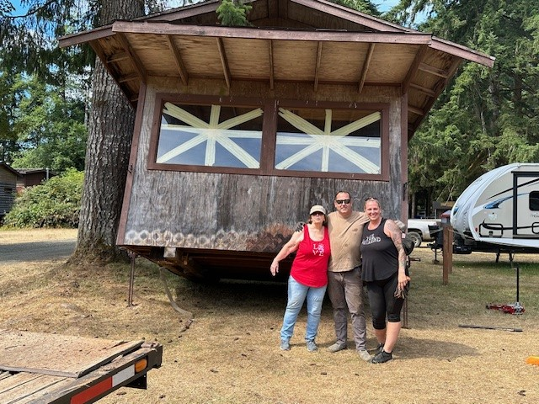
Ron Enstrom- Vice president position

Hello, I am Ron Enstrom I am running for Vice president. In the early 2000’s I was on the board of WWP for 7 years, I was part of the process of getting our new water system going. I stepped down because I needed to be a dad, like spending time with my daughter Ronni. I needed to take her to the park, play in the pool, and do dad things. Somewhere around 2016 I ran for president, and I was elected president again. That year we were down to just two caretakers so I had to go out and help the caretakers do their work. I would mow for them I would start Monday and end Thursday. The mowing took about 17 hours. Dustin and Amanda would do the weed-eating. Dustin would mow the play park on Friday. That took Dustin about 3 hours. We also managed to get the last of the water system done on top of the hill. In the fall. Also got the caretaker's house done. Ronni, my daughter, is graduating this year so I have the time to be your next Vice President. It would be my pleasure to be a part of the board to serve all the WWP members.

Sheldon Swope- Postion 7 (unopposed)
Hello everyone, my name is Sheldon Swope and I was born and raised in Aberdeen. I've worked at Earley tire truck shop for 24 years. I've enjoyed WWP for as long as I can remember. We finally bought our own lot, M44 in 2005. Our two kids have grown up out here enjoying the river, pool, riding bikes, and camping. I'm running for seat 7. I feel like I would be a good fit for the position. I'm always willing to help, when and where needed.

